Thematic school
Analysing and modelling phenotypes
for challenging environments
28 May – 1 June 2018

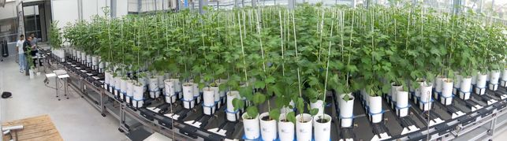
Application form
(complete this form in English and send it back before 6 April 2018 to agnes.seye@cirad.fr)

First name
Family name
Gender
Nationality
Date of birth
Telephone
E-mail

Studies
Discipline
Highest degree

Current position
Your current position
(if you are a PHD, please precise
1st, 2nd or 3rd year)
Name of home institute
or school
Address of home institute
or school
Matricule ADUM (if concerned)
Title and description
of your ongoing PhD/research
project
Your publications (if any)
related to this PhD course
Prerequisites
Please provide evidence that you can follow a whole week course
in English
Give evidence that you can use
standard procedures in Excel

Expectations
Why would you like to follow this thematic school?

Financial support
Do you apply for financial support (plane tickets and/or accommodation)?

Thank you for applying for this course.

