Thematic school
Analysing and modelling phenotypes
for challenging environments
12-16 June, 2017

Application form
(complete this form in English and send it back before 30.04.2017 to agnes.seye@cirad.fr)

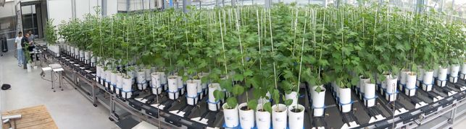

First name
Family name
Gender
Nationality
Date of birth
Telephone
E-mail

Studies
Discipline
Highest degree

Current position
Your current position
(if you are a PHD, please precise
1st, 2nd or 3rd year)
Name
of home institute or school
Address
of home institute or school
Matricule ADUM (if concerned)
Title and description
of your ongoing PhD/research project
Your publications (if any)
related to this PhD course

Prerequisites
Please provide evidence that you can follow
a whole week course in English
Give evidence that you can use standard procedures in Excel

Expectations
Why would you like to follow this thematic school?

Financial support
Do you apply for financial support (plane tickets and/or accommodation)?

Thank you for applying for this course.

